Module Splitter: An Adaptive Semantic Tree Structuring

A Major Project Report
Submitted by

Nitish | 220120101112
Nitin Kumar | 220120101111
Mohd. Aasif | 220120101101
Himanshi Pandey | 730120101012
Sonu Kumar | 220120101162

Under the Supervision of
Mr. Upendra Verma
Assistant Professor

Department of Computer Science & Engineering

In Partial Fulfillment of the Requirements
for the Degree of
Bachelor of Technology

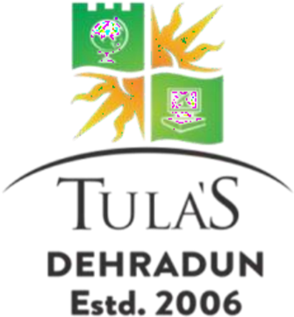

DEPARTMENT OF COMPUTER SCIENCE & ENGINEERING
TULA’S INSTITUTE, DEHRADUN
(Affiliated to VMSB Uttarakhand Technical University, Dehradun)

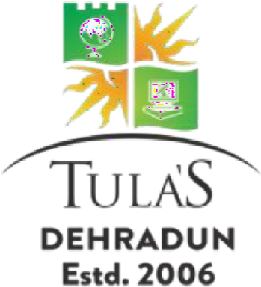
DECLARATION

We, declare that the work embodied in this Project report is our own original work carried out by us under the supervision of Mr. Upendra Verma (Assistant Professor ,Dept. of CSE), for the session 2025-26 at Tula’s Institute, Dehradun. The matter embodied in this Project report has not been submitted elsewhere for the award of any other degree. We declare that we have faithfully acknowledged, given credit to and referred to the researchers wherever the work has been cited in the text and the body of the report. We further certify that we have not wilfully lifted up some other’s work, para, text, data, results, etc. reported in the journals, books, magazines, reports, dissertations, thesis or available at websites and have included them in this project report and cited as our own work.

Date: 24/05/2026 Nitish
Place: Dehradun Nitin Kumar
Mohd. Aasif
Himanshu Pandey
Sonu Kumar

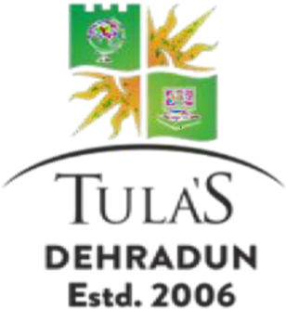

Certificate from the Supervisor/Co-supervisor

This is to certify that the Project Report entitled:
“Module Splitter: An Adaptive Semantic Tree Structuring”

Submitted by:
Nitish | 220120101112
Nitin Saini | 220120101111
Mohd. Aasif | 220120101101
Himanshu Pandey | 730120101012
Sonu Kumar | 220120101162

at Tula’s Institute, Dehradun for the degree of Bachelor of Technology is their original work carried out by them under my guidance and supervision. This work is fully or partially has not been submitted for the award of any other degree or diploma. The assistance and help taken during the course of the study has been duly acknowledged and the source of literature amply recorded.
Supervisor Signature :
Supervisor Name : Mr. Upendra Verma
Supervisor Designation : Assistant Professor
Date : 24/05/26

